April 17, 2010 Sam Palmer
Global witness starts campaign against blood diamonds
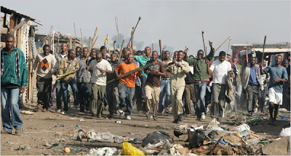
On Tuesday April 17 global witness announced a new campaign to stop the funding of African militias in Africa, as well as their other campaigns, their new campaign to stop the funding of blood diamonds will not only reduce arms conflicts but help families in Africa stricken by the violence and slavery involved with these conflict diamonds. Global witness uses donations from any willing individual or government, to help raise awareness. “we’re looking to stop the issues involved with the human rights abuse more than the funding of military action” says CEO Charmian Gooch, global witness looks to help the families affected by violent instability and the families torn apart through these conflicts.
African citizens rioting aver the slavery and abuse
Issues revolving around human rights abuse are more of a concern to global witness than the producing of blood diamonds because stopping the violence and slavery is putting a bigger impact on Africa than the funding of military action. The people of Africa are outraged and helpless against the African militias and they demand an end to the abuse and with the help of global witness, they are one step closer. Global witness except donations from anyone and you can help they people in Africa by getting involved, help spread they word and donate to their cause. Stopping these rights abuses and diamond funding will help stop the underground militias and overall make Africa a better place and allow the people to live their lives un affected by violence and slavery.

